Федеральное государственное бюджетное образовательное учреждение
высшего образования
«Саратовский государственный технический университет
имени Гагарина Ю.А.»

Кафедра «Прикладные информационные технологии»

ОТЧЕТ
по лабораторной работе №9

Студента гр. б2-ПИНФ21:
Нефедова Данила Вадимовича
Проверил доцент кафедры ПИТ:
Бровко Александр Валерьевич

Саратов 2019
1

ts(1:10, frequency = 4, start = c(1959, 2))

z <- ts(matrix(rnorm(300), 100, 3), start = c(1961, 1), frequency = 12)

plot(z, plot.type = "single", lty = 1:3)

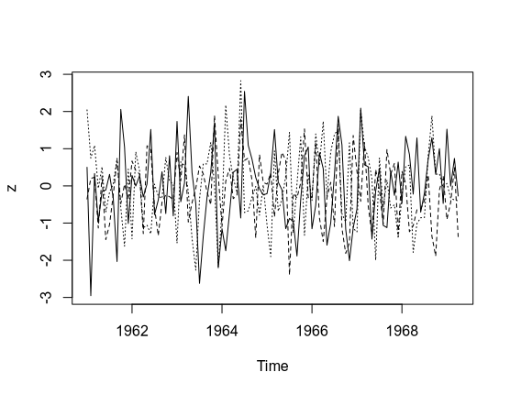

2

leaf <- read.table("data/leaf2-4.txt", head = TRUE, as.is = TRUE, sep=";")

forma <- ts(leaf$FORM, frequency = 36)

acf(forma)
plot(stl(forma, s.window = "periodic")$time.series)

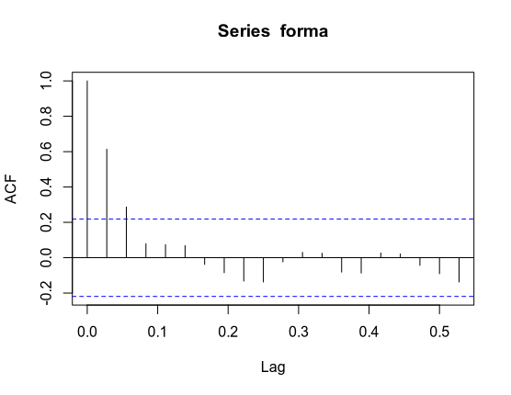
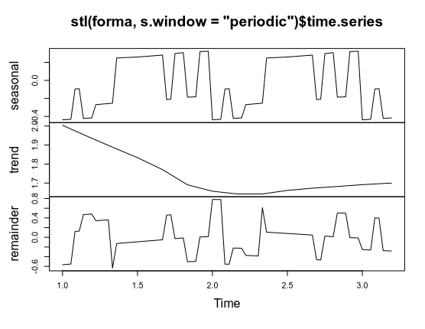

3

leaf <- read.table("data/leaf2-4.txt", head = TRUE, as.is = TRUE, sep=";")

forma <- ts(leaf$K.UVL, frequency = 36)

acf(forma)
plot(stl(forma, s.window = "periodic")$time.series)

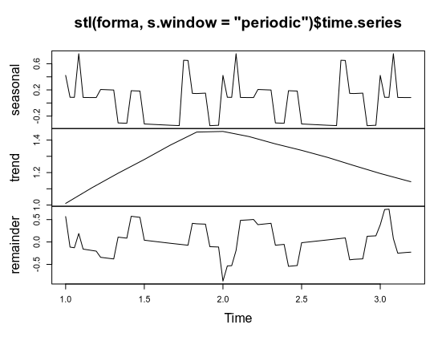

4

polzovateli <- ts(read.table("data/data.txt")$V3, start=c(2004,12), frequency=12)

cum.polzovateli <- ts(cumsum(polzovateli), start=c(2004,12), frequency=12)

oldpar <- par(mfrow=c(2,1))
plot(polzovateli, type="b", log="y", xlab="")
plot(cum.polzovateli, type="b", ylim=c(1,3000), log="y")
par(oldpar)

model01 <- arima(cum.polzovateli, order=c(0,0,1))
model02 <- arima(cum.polzovateli, order=c(0,0,2))
model03 <- arima(cum.polzovateli, order=c(0,0,3))
model04 <- arima(cum.polzovateli, order=c(0,0,4))
model05 <- arima(cum.polzovateli, order=c(0,0,5))
model06 <- arima(cum.polzovateli, order=c(0,0,6))
model07 <- arima(cum.polzovateli, order=c(0,0,7))
model08 <- arima(cum.polzovateli, order=c(0,0,8))
model09 <- arima(cum.polzovateli, order=c(0,0,9))
model010 <- arima(cum.polzovateli, order=c(0,0,10))
model011 <- arima(cum.polzovateli, order=c(0,0,11))
model012 <- arima(cum.polzovateli, order=c(0,0,12))
model013 <- arima(cum.polzovateli, order=c(0,0,13))
model014 <- arima(cum.polzovateli, order=c(0,0,14))

plot(AIC(model01, model02, model03, model04, model05, model06, model07, model08, model09, model010, model011, model012, model013, model014), type="b")

model012 <- arima(cum.polzovateli, order=c(0,0,12))
model112 <- arima(cum.polzovateli, order=c(1,0,12))
model212 <- arima(cum.polzovateli, order=c(2,0,12))
model312 <- arima(cum.polzovateli, order=c(3,0,12))
model412 <- arima(cum.polzovateli, order=c(4,0,12))

AIC(model012, model112, model212, model312, model412)

model2120 <- arima(cum.polzovateli, order=c(2,0,12))
model2121 <- arima(cum.polzovateli, order=c(2,1,12))
model2122 <- arima(cum.polzovateli, order=c(2,2,12))
model2123 <- arima(cum.polzovateli, order=c(2,3,12))
model2124 <- arima(cum.polzovateli, order=c(2,4,12))
model2125 <- arima(cum.polzovateli, order=c(2,5,12))
AIC(model2120, model2121 ,model2122, model2123, model2124)

plot(cum.polzovateli, xlim=c(2004.7,2010), ylim=c(0,6500))
lines(predict(model2123, n.ahead=12, se.fit = TRUE)$pred, col="green")
lines(predict(model2123, n.ahead=12, se.fit = TRUE)$se + predict(model2123, n.ahead=12, se.fit = TRUE)$pred, col="red")
lines(-predict(model2123, n.ahead=12, se.fit = TRUE)$se + predict(model2123, n.ahead=12, se.fit = TRUE)$pred, col="red")

round(predict(model2123, n.ahead=12, se.fit = TRUE)$se + predict(model2123, n.ahead=12, se.fit = TRUE)$pred)

round(-predict(model2123, n.ahead=12, se.fit = TRUE)$se + predict(model2123, n.ahead=12, se.fit = TRUE)$pred)

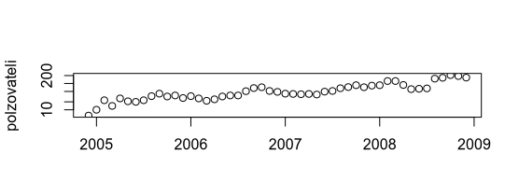
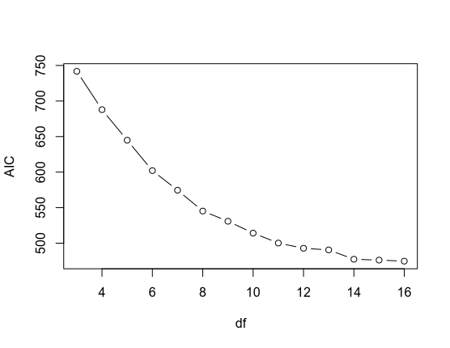
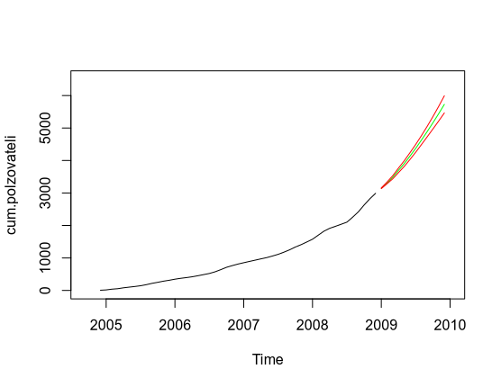

5

dollar <- read.table('data/dollar.txt')[,3]
dollar <- ts(dollar, start = c(06, 01), frequency = 30.5)
oldpar <- par(mfrow=c(2,1))

par(oldpar)

dol <- read.table('data/dol.txt')[,3]
oldpar <- par(mfrow=c(2,1))
dollar <- ts(dol, start = c(06, 01), frequency = 30.5)

oldpar <- par(mfrow=c(2,1))

model01 <- arima(dollar, order=c(0,0,1))
model02 <- arima(dollar, order=c(0,0,2))
model03 <- arima(dollar, order=c(0,0,3))
model04 <- arima(dollar, order=c(0,0,4))
model05 <- arima(dollar, order=c(0,0,5))
model06 <- arima(dollar, order=c(0,0,6))
model07 <- arima(dollar, order=c(0,0,7))
model08 <- arima(dollar, order=c(0,0,8))
model09 <- arima(dollar, order=c(0,0,9))
model010 <- arima(dollar, order=c(0,0,10))
model011 <- arima(dollar, order=c(0,0,11))
model012 <- arima(dollar, order=c(0,0,12))
model013 <- arima(dollar, order=c(0,0,13))
model014 <- arima(dollar, order=c(0,0,14))

plot(AIC(model01, model02, model03, model04, model05, model06, model07, model08, model09, model010, model011, model012, model013, model014), type="b")

model07 <- arima(dollar, order=c(0,0,7))
model107 <- arima(dollar, order=c(1,0,7))
model207 <- arima(dollar, order=c(2,0,7))
model307 <- arima(dollar, order=c(3,0,7))
model407 <- arima(dollar, order=c(4,0,7))

AIC(model07, model107, model207, model307, model407)

model2070 <- arima(dollar, order=c(2,0,7))
model2071 <- arima(dollar, order=c(2,1,7))
model2072 <- arima(dollar, order=c(2,2,7))
model2073 <- arima(dollar, order=c(2,3,7))
model2074 <- arima(dollar, order=c(2,4,7))
model2075 <- arima(dollar, order=c(2,5,7))
model2076 <- arima(dollar, order=c(2,6,7))

AIC(model2070, model2071, model2072, model2073, model2074, model2075)

max(dollar)

max(dollar)
min(dollar)

lines(predict(model2070, n.ahead=12, se.fit = TRUE)$pred, col="green")
lines(predict(model2070, n.ahead=12, se.fit = TRUE)$sepredict(model2123, n.ahead=12, se.fit = TRUE)$pred, col="red")
lines(predict(model2070, n.ahead=12, se.fit = TRUE)$sepredict(model2070, n.ahead=12, se.fit = TRUE)$pred, col="red")
lines(predict(model2070, n.ahead=12, se.fit = TRUE)$se + predict(model2070, n.ahead=12, se.fit = TRUE)$pred, col="red")
lines(-predict(model2070, n.ahead=12, se.fit = TRUE)$se + predict(model2070, n.ahead=12, se.fit = TRUE)$pred, col="red")

lines(predict(model2070, n.ahead=12, se.fit = TRUE)$sepredict(model2123, n.ahead=12, se.fit = TRUE)$pred, col="red")
lines(predict(model2070, n.ahead=12, se.fit = TRUE)$pred, col="green")
lines(predict(model2070, n.ahead=12, se.fit = TRUE)$sepredict(model2123, n.ahead=12, se.fit = TRUE)$pred, col="red")
lines(-predict(model2070, n.ahead=12, se.fit = TRUE)$se + predict(model2070, n.ahead=12, se.fit = TRUE)$pred, col="red")
lines(predict(model2070, n.ahead=12, se.fit = TRUE)$se + predict(model2070, n.ahead=12, se.fit = TRUE)$pred, col="red")

full_doll <- read.table('data/dollar.txt')[,3]
full_doll <- read.table('data/dollar.txt')[,3]
full_doll <- ts(full_doll, start=c(06.01), frequency=30,5)
f_dollar <- read.table('data/dollar.txt')[,3]
full_dollar <- ts(f_dollar, start = c(06, 01), frequency = 30.5)

plot(full_dollar, xlim=c(06.01,08.10), ylim=c(27.6,28.4))

lines(predict(model2070, n.ahead=12, se.fit = TRUE)$pred, col="green")
lines(predict(model2070, n.ahead=12, se.fit = TRUE)$sepredict(model2123, n.ahead=12, se.fit = TRUE)$pred, col="red")
lines(predict(model2070, n.ahead=12, se.fit = TRUE)$sepredict(model2070, n.ahead=12, se.fit = TRUE)$pred, col="red")
lines(predict(model2070, n.ahead=12, se.fit = TRUE)$se + predict(model2070, n.ahead=12, se.fit = TRUE)$pred, col="red")
lines(-predict(model2070, n.ahead=12, se.fit = TRUE)$se + predict(model2070, n.ahead=12, se.fit = TRUE)$pred, col="red")

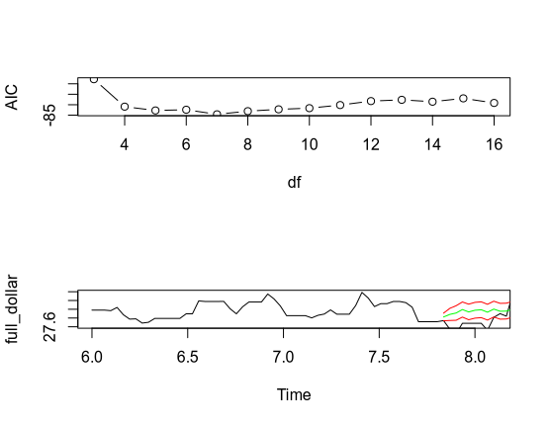
6

forma <- ts(nhtemp, frequency=1)
acf(forma, main="")
plot(stl(forma, s.window="periodic")$time.series, main="")

